

CP Lab-07 Tasks

Name: Syed Muhammad Raza Ali

Enrolment: 02-134231-028

Course: CP Lab

Faculty: Miss Fatima

**Lab 07 Functions 1**

**Task 01**

Create a calculator that takes a number, a basic math operator (+,-,*,/,^), and a second number all from user input, and have it print the result of the mathematical operation. The mathematical operations should be wrapped inside of functions.

Code:

#include <iOStream>

#include <cmath>

using namespace std;

int add(int a,int b){

int c = a+b;

return c;

}

int sub(int a,int b){

int c = a-b;

return c;

}

int mul(int a,int b){

int c = a*b;

return c;

}

int divide(int a,int b){

int c = a/b;

return c;

}

int power(int a, int b) {

int c = pow(a, b);

return c;

}

int main(){

int a,b;

cout << "Enter a"<<endl;

cin >>a;

cout << "Enter b"<<endl;

cin >>b;

cout <<"The sum of " <<a<<" and "<<b<<" is "<<add(a,b)<<endl;

cout <<"The sub of " <<a<<" and "<<b<<" is "<<sub(a,b)<<endl;

cout <<"The mul of " <<a<<" and "<<b<<" is "<<mul(a,b)<<endl;

cout <<"The div of " <<a<<" and "<<b<<" is "<<divide(a,b)<<endl;

cout << "The power of " << a << " to " << b << " is " << power(a, b) << endl;

}

Output:

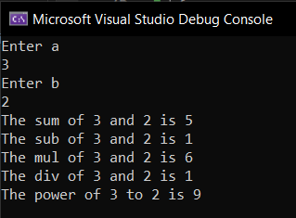

**Task 02**

Write a program to print the factorial of a number by defining a function named 'Factorial'.  
Factorial of any number n is represented by n! And is equal to 1*2*3*….*(n-1)*n

Code:

int f(int a){

int factorial=1;

for(int i=1;i<=a;i++){

factorial = factorial*i;

}

return factorial;

}

int main(){

int a;

cout <<"Enter the number to find the factorial"<<endl;

cin>>a;

cout <<"The factorial of "<<a<<" is "<<f(a);

}

Output:

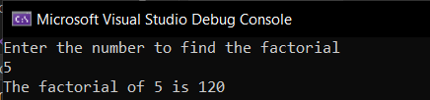

**Task 03**

Write a C++ program in which a person is eligible to vote if his/her age is greater than or equal to 18. Define a function to find out if he/she is eligible to vote.

Code:

#include <iOStream>

using namespace std;

string print(int age) {

if (age >= 18) {

string str = "You are eligible to vote";

return str;

}

else {

string str = "You are not eligible to vote";

return str;

}

}

int main() {

int age;

cout << "Enter your age" << endl;

cin >> age;

cout << print(age);

}

Output (if age<18):

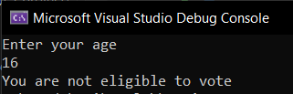

Output (if age>=18):

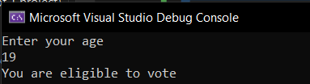

**Task 04**

Mr. A purchases online grocery from ABC superstore, ABC superstore offers free delivery on orders above Rs. 1000, otherwise they charge Rs. 150 as delivery charges. Write a function to calculate total delivery charges.

Code:

#include <iOStream>

#include <string>

using namespace std;

string output(int total) {

if (total > 1000) {

string str = "As your total is greater than 1000, so you will get free delivery";

return str;

}

else {

string str = "Your total is less than 1000, so a fees of 150 will be charged";

return str;

}

}

int main() {

int total;

cout << "Enter the total amount" << endl;

cin >> total;

cout << output(total);

}

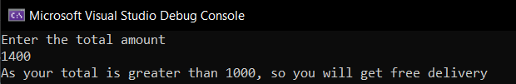Output (if total>1000):

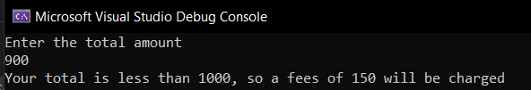Output (if total<1000):

**Task 05**

Solve the following problems using function In C++.

1. Write a program in which swap two numbers.
2. Find weather the number is prime or not.
3. Find weather the number is even or odd.

Code:

#include <iOStream>

using namespace std;

int main() {

char choice, option;

do

{

cout << "Press 1 to swap two numbers" << endl

<< "Press 2 find whether a number is prime or not" << endl

<< "Press 3 to find whether a number is even or not" << endl;

cin >> choice;

if (choice == '1') {

int a, b;

cout << "Enter a number" << endl;

cin >> a;

cout << "Enter another number" << endl;

cin >> b;

cout << "Before swapping ---> a = " << a << " and b = " << b << endl;

int temp = 0;

temp = b;

b = a;

a = temp;

cout << "After swapping ---> a = " << a << " and b = " << b << endl;

}

else if (choice == '2') {

int num3;

bool flag = true;

cout << "Enter a number" << endl;

cin >> num3;

for (int i = 2; i < num3; i++) {

if (num3 % i == 0) {

flag = false;

cout << "The number is not prime" << endl;

break;

}

}

if (flag == true) {

cout << "The number is prime" << endl;

}

}

else if (choice == '3') {

int x;

cout << "Enter a number" << endl;

cin >> x;

if (x % 2 == 0) {

cout << x << " is an even number" << endl;

}

else {

cout << x << " is an odd number" << endl;

}

}

else {

cout << "Invalid choice" << endl;

}

cout << "Press 0 to return to the main menu or any other key to exit" << endl;

cin >> option;

} while (option == '0');

return 0;

}

Output:

